Module Six Assignment: Cartpole Revisited

Grace Fletcher
Southern New Hampshire University
CS 370: Current/Emerging Trends in Computer Science
Dr. Alexander Voitenko
April 12th, 2026

Explain how the cartpole problem can be solved using the REINFORCE algorithm.
According to the article “Deriving Policy Gradients and Implementing REINFORCE” written by Chris Yoon, “REINFORCE is a Monte-Carlo variant of policy gradients (Monte-Carlo: taking random samples). The agent collects a trajectory τ of one episode using its current policy, and uses it to update the policy parameter. Since one full trajectory must be completed to construct a sample space, REINFORCE is updated in an off-policy way.” (Yoon, 2018) Pseudo code for REINFORCE, based off Yoon’s article, can be represented by the following:
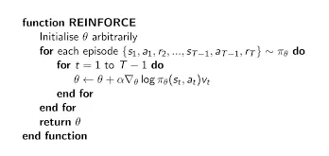
In short, the flow the algorithm takes is as follows: It performs a trajectory roll-out using the current policy, and it then stores log probabilities and reward values at each step. After this, it calculates discounted cumulative future rewards at each step and then computes policy gradients and updates the policy parameter. It then repeats this cycle. (Yoon, 2018) The results of implementing this into the cartpole problem are longer episodes, allowing the agent to learn to balance the pole for a longer time. (Yoon, 2018)
Explain how the cartpole problem can be solved using the A2C algorithm.
The Advantage Actor Critic (A2C) algorithm is a reinforcement learning algorithm that combines policy-based and value-based reinforcement algorithms together. According to the article “Advantage Actor Critic Tutorial: A2C” written by Mike Wang, the A2C algorithm can be summarized as follows: “The actor critic algorithm consists of two networks (the actor and the critic) working together to solve a particular problem. At a high level, the Advantage Function calculates the agent’s TD Error or Prediction Error. The actor network choses an action at each time step and the critic network evaluates the quality or the Q-value of a given input state. As the critic network learns which states are better or worse, the actor uses this information to teach the agent to seek out good states and avoid bad states.” (Wang, 2021)
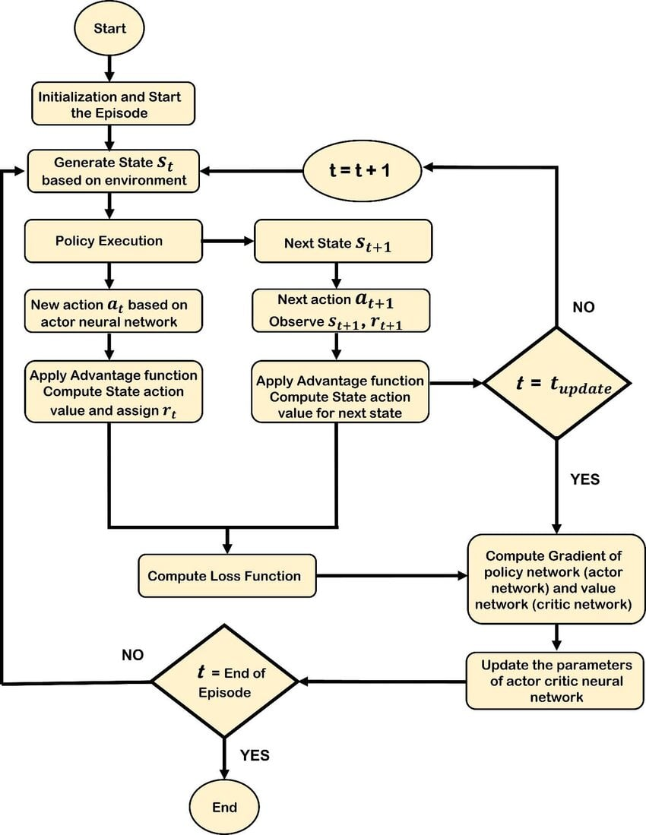
Figure i: Flowchart from ResearchGate Journal (Mahmood et al., 2024)
To solve the cartpole problem with the A2C algorithm, the agent would accept 4 input states at each timestep and would then choose to move either left or right. The input states would include cart position, cart velocity, pole angle, and pole velocity (specifically that the tip). The end goal with this algorithm is to keep the pole balanced for as long as possible. (Wang, 2021) After implementation, the result is the actor learning from an increasingly accurate TD error to decide if an action was right or wrong. According to the article, “Because the algorithm starts out with the critic having no knowledge of the environment, the actor similarly can’t learn much from the critic. As the critic starts to make more and more accurate predictions, the calculated TD error (Advantage) becomes more accurate. The actor is able to learn from the increasingly accurate TD error to decide if a move was good or bad.” (Wang, 2021)
Explain how policy gradient approaches differ from value-based approaches, such as Q-Learning.
In value-based approaches, like Q-Learning, the agent within the learning model fills out a Q-Table with Q-Values to learn and figure out what actions are best for a given situation. With policy gradient approaches, the agent changes the policy directly as opposed to using Q-Values to do so. According to the article “Policy Gradient methods vs Q-Learning” written by Walkerastro, “But as things get more complex, like with bigger or more continuous environments, Q-Learning can start to struggle. That’s where Policy Gradient methods, like the REINFORCE algorithm, come in. Instead of messing with Q-values, these methods focus on tweaking the policy directly, which makes them better suited for tougher tasks. So, if you’re dealing with a more complex environment, Policy Gradient methods might be the way to go.” (Walkerastro, 2024)
Explain how actor-critic approaches differ from value- and policy-based approaches.
Actor-critic approaches combine value-based and policy-based approaches together to form the actor-critic network base of the algorithm. According to the A2C tutorial written by Mike Wang, “In the field of Reinforcement Learning, the Advantage Actor Critic (A2C) algorithm combines two types of Reinforcement Learning algorithms (Policy Based and Value Based) together. Policy Based agents directly learn a policy (a probability distribution of actions) mapping input states to output actions. Value Based algorithms learn to select actions based on the predicted value of the input state or action.” (Wang, 2021)

References
Mahmood, J., Raja, M. A., Loane, J., & Caffery, F. M. (2024). Development of a Distributed and Scalable Testbed for UAVs using Reinforcement Learning . ResearchGate. https://doi.org/10.21203/rs.3.rs-5372115/v1
Walkerastro. (2024, August 28). Policy Gradient methods vs Q-Learning - Walkerastro - Medium. Medium. https://medium.com/@walkerastro41/policy-gradient-methods-vs-q-learning-c9f513f63d3d
Wang, M. (2021, January 22). Advantage Actor Critic Tutorial: minA2C | Towards Data Science. Towards Data Science. https://towardsdatascience.com/advantage-actor-critic-tutorial-mina2c-7a3249962fc8/
Yoon, C. (2018, December 30). Deriving Policy Gradients and Implementing REINFORCE. Medium. https://medium.com/@thechrisyoon/deriving-policy-gradients-and-implementing-reinforce-f887949bd63

